Lab: Associative Arrays, Lambda and Stream API
Problems for exercises and homework for the "Programming Fundamentals" course @ SoftUni.
You can check your solutions in Judge.

Associative Arrays

Count Real Numbers
Read a list of real numbers and print them in ascending order along with their number of occurrences.

Examples
Input | Output |  | Input | Output |  | Input | Output
8 2 2 8 2 | 2 -> 3  8 -> 2 |  | 1 5 1 3 | 1 -> 2  3 -> 1  5 -> 1 |  | -2 0 0 2 | -2 -> 1  0 -> 2  2 -> 1

Solution
Read an array of real numbers (double).
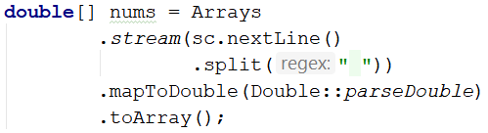
Use TreeMap<Double, Integer> named counts.
Pass through each input number num and increase counts (when num exists in the map) or add it with value 1.
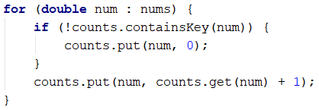
Pass through all numbers num in the map and print the number and its count of occurrences after formatting it to a decimal place without trailing zeros (otherwise, the output will have too many decimal places, e.g., 2.500000 instead of 2.5);
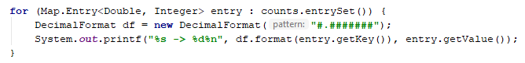

Word Synonyms
Write a program that keeps a map with synonyms. The key to the map will be the word. The value will be a list of all the synonyms of that word. You will be given a number n. On the next 2 * n lines, you will be given the word and a synonym each on a separate line like this:
- {word}
- {synonym}
If you get the same word for the second time, just add the new synonym to the list.
Print the words in the following format:
{word} - {synonym1, synonym2… synonymN}

Examples
Input | Output
3  cute  adorable  cute  charming  smart  clever | cute - adorable, charming  smart - clever
2  task  problem  task  assignment | task – problem, assignment

Hints
- Use LinkedHashMap (String -> ArrayList<String>) to keep track of all words.
- Read 2 * n lines.
- Add the word in the Map if it is not present.
- Add the synonym as value to the given the word.
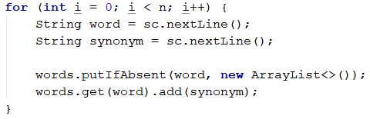
- Print each word with the synonyms in the required format specified above.

Odd Occurrences
Write a program that extracts from a given sequence of words all elements that are present in it an odd number of times (case-insensitive).
- Words are given in a single line, space-separated.
- Print the result elements in lowercase in their order of appearance.

Examples
Input | Output
Java C# PHP PHP JAVA C java | java, c#, c
3 5 5 hi pi HO Hi 5 ho 3 hi pi | 5, hi
a a A SQL xx a xx a A a XX c | a, sql, xx, c

Hints
Read a line from the console and split it by a space:
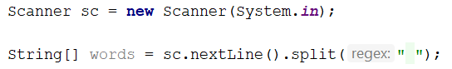
Use a LinkedHashMap (String -> int) to count the occurrences of each word:
Pass through all elements in the array and count each word:
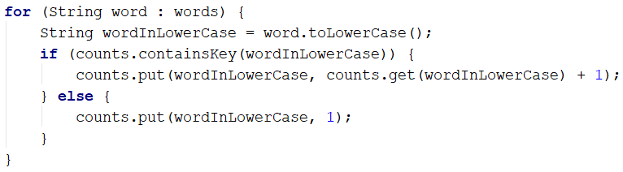
Create a new ArrayList (String), which will hold all the words with odd occurrences:
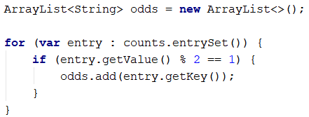
Now all that is left is to print the words, separated by a comma and a single space (", ").
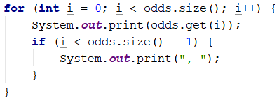

Stream API

Word Filter
Read an array of strings, and take only words whose length is even. Print each word on a new line.

Examples
Input | Output
kiwi orange banana apple | kiwi  orange  banana
pizza cake pasta chips | cake
- Read an array of strings.
- Filter those whose length is even.
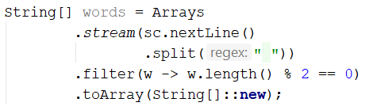
- Print each word on a new line.

